# Project Name: Validation of the User Login.

## Output:

### Landing Page:

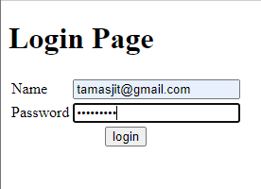

### Dashboard Page:

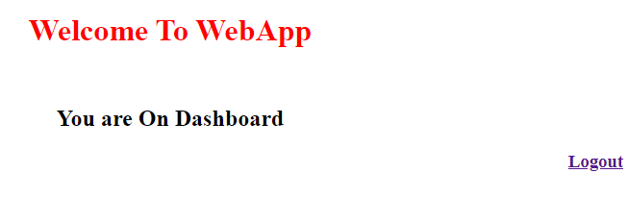

### Logout Page:

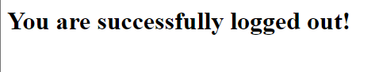

### Wrong Credential input:

